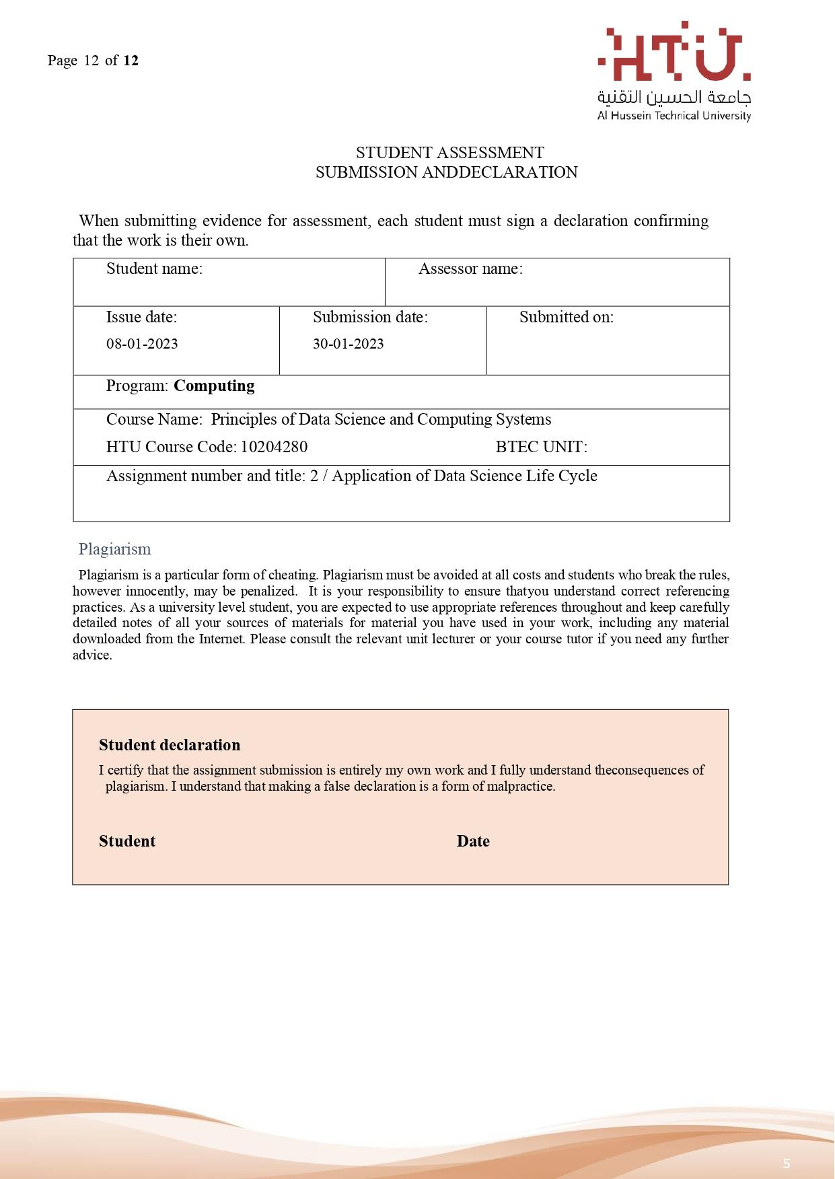

30/1/2023

Saif haddad

30/1/2023

Dr.Murad yaghi

Saif Kamal Haddad